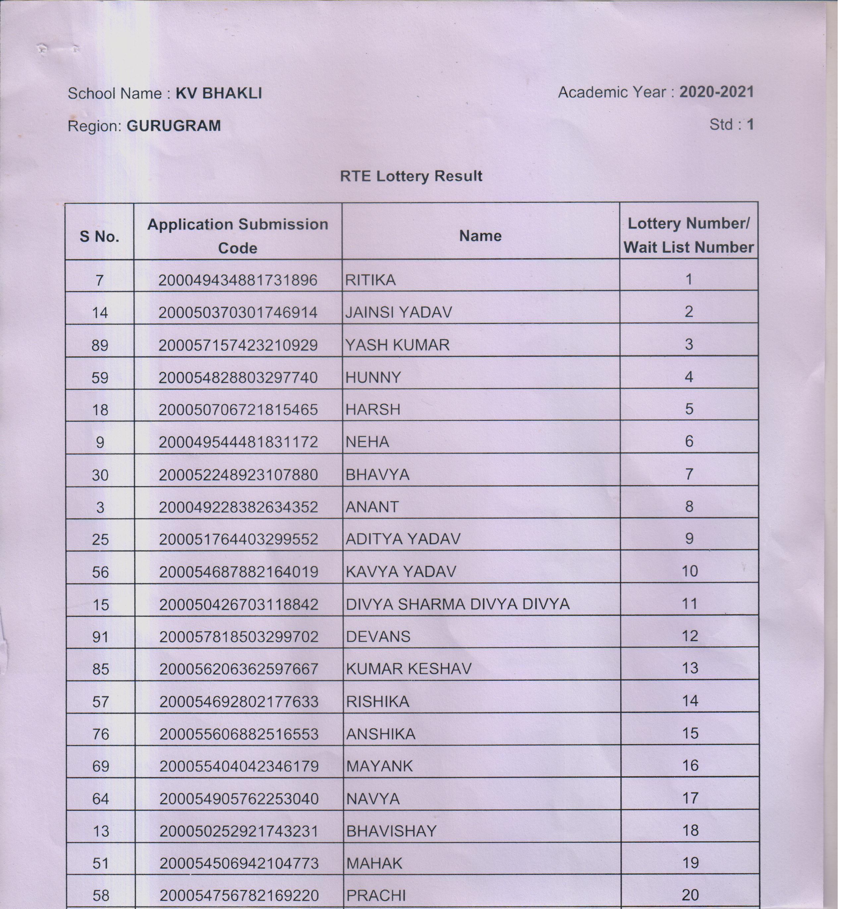 TOTAL-20 CANDIDATES
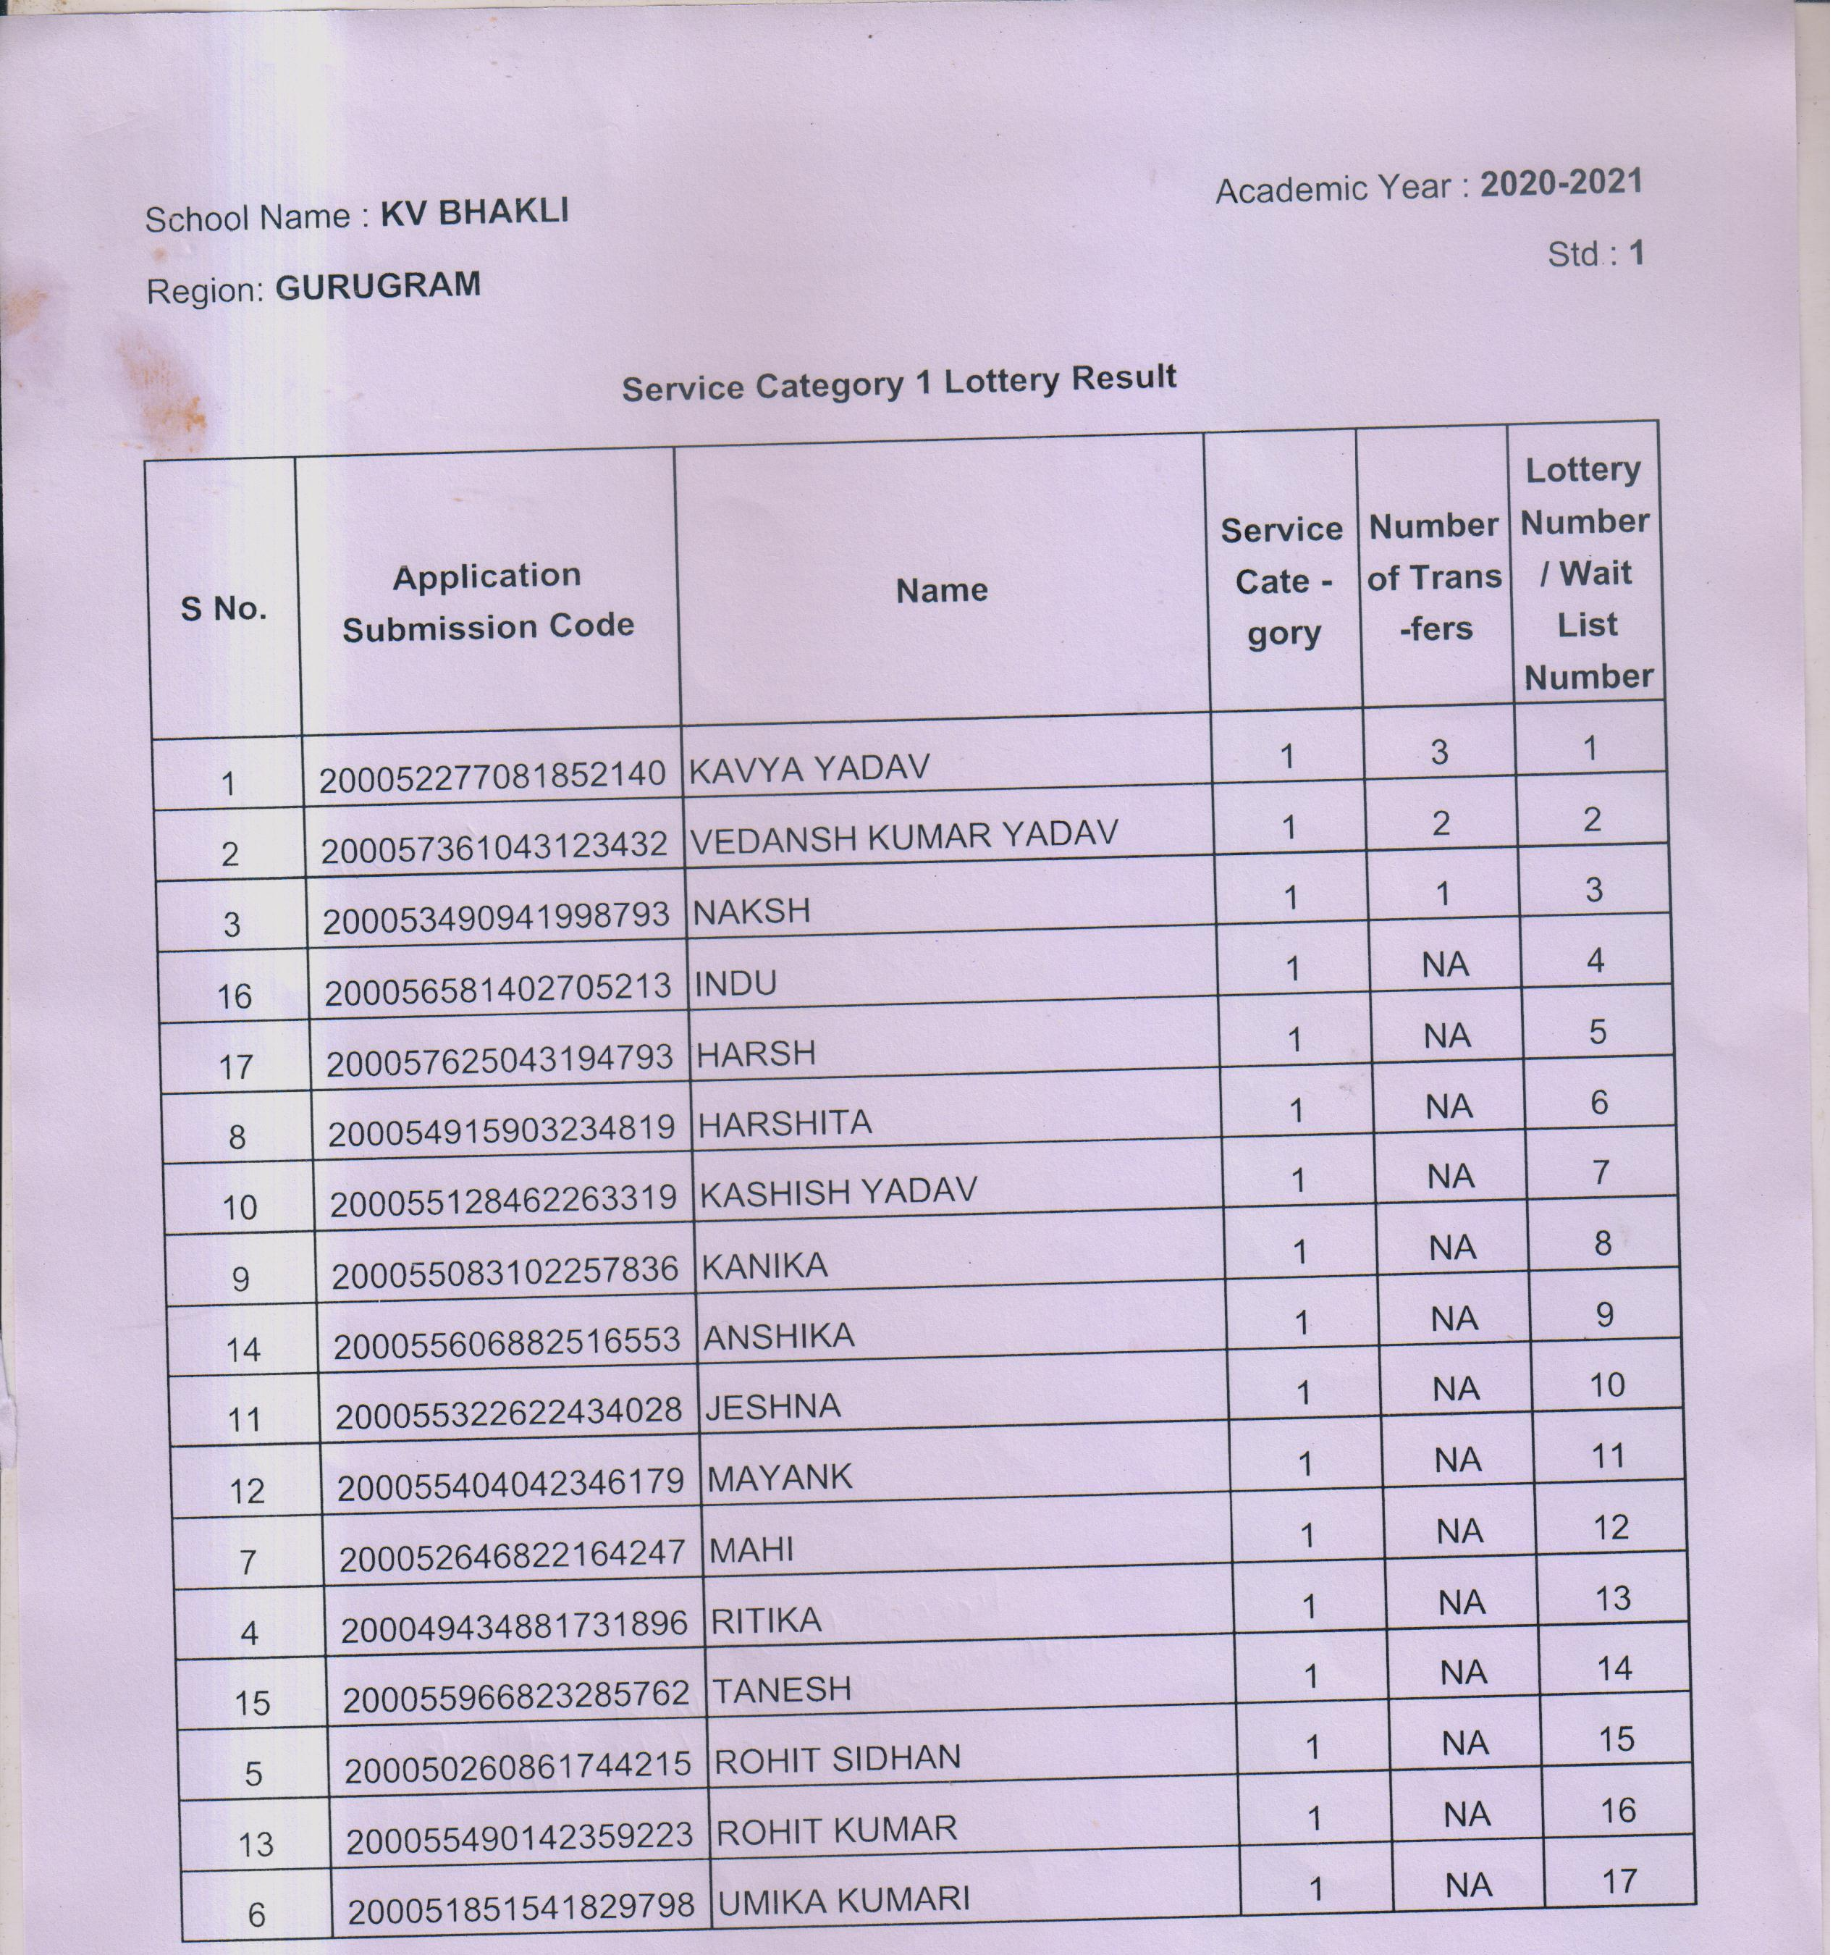 TOTAL-17 CANDIDATES

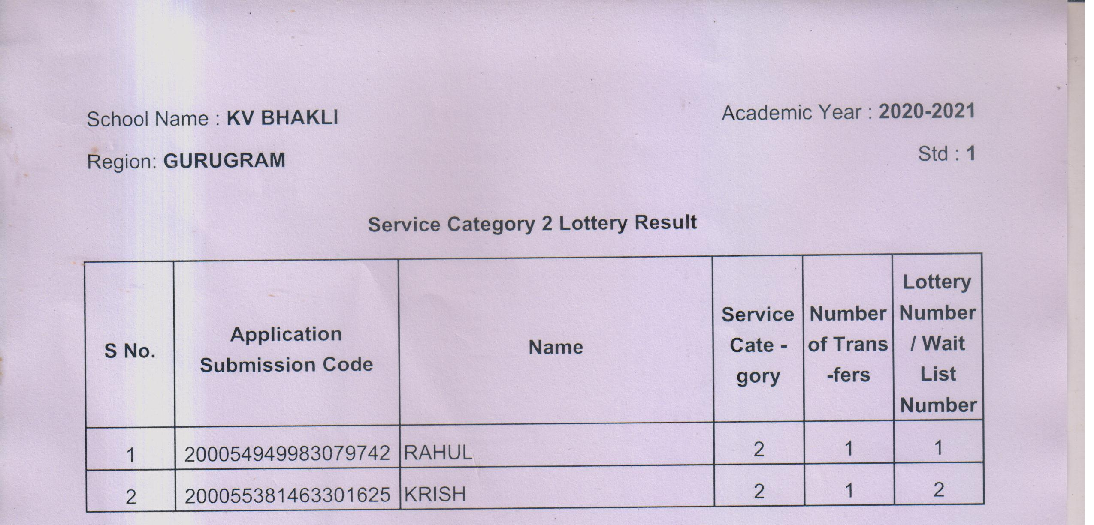
TOTAL-02 CANDIDATES
School Name:- KV Bhakli Acadmic Year: 2020-21
Region: Gurugram Std : 1
SAQ(TOTAL-10 CANDIDATES)
S No. | Application Code | Name | Service Cate - gory | Number of Trans -fers | Lottery Number / Wait List Number
2 | 200050252921743231 | BHAVISHAY | 3 | NA | 1
1 | 200049561361828344 | TANISHI | 3 | NA | 2
6 | 200055614362429945 | VRIDHI YADAV | 3 | NA | 3
3 | 200052813161989860 | ANSHIKA | 3 | NA | 4
5 | 200055460002515208 | DIVYA YADAV | 3 | NA | 5
4 | 200053533702690701 | ASHWANI | 3 | NA | 6
1 | 200054875223126004 | TANISHA | 4 | 1 | 7
2 | 200057157423210929 | RAHUL | 4 | NA | 8
3 | 200054692802177633 | RISHIKA | 4 | NA | 9
4 | 200058323463308938 | HARIT | 4 | NA | 10
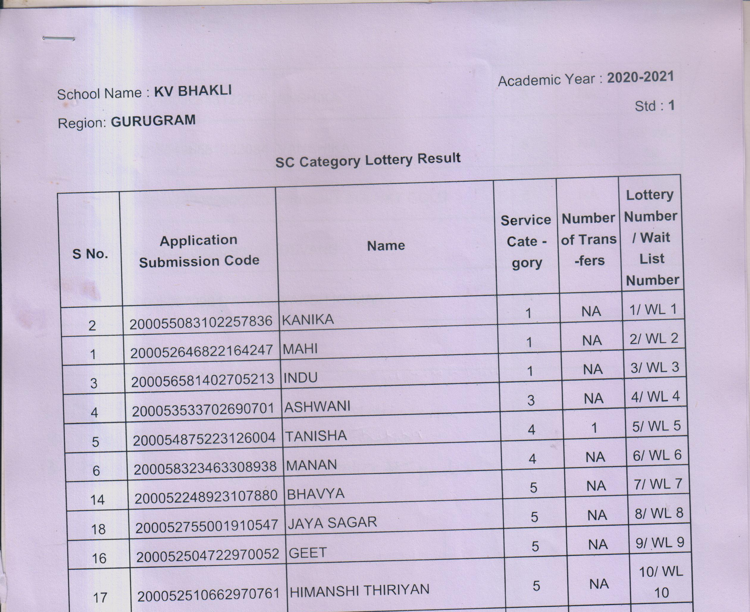
TOTAL - 03CANDIDATES (Lottery no.8.9.10)
(lottery no 1 to 7selected under RTE/Other service categories)

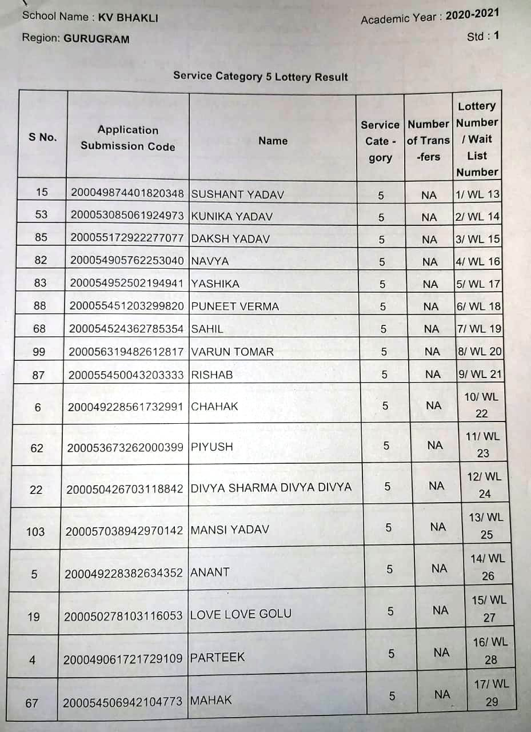
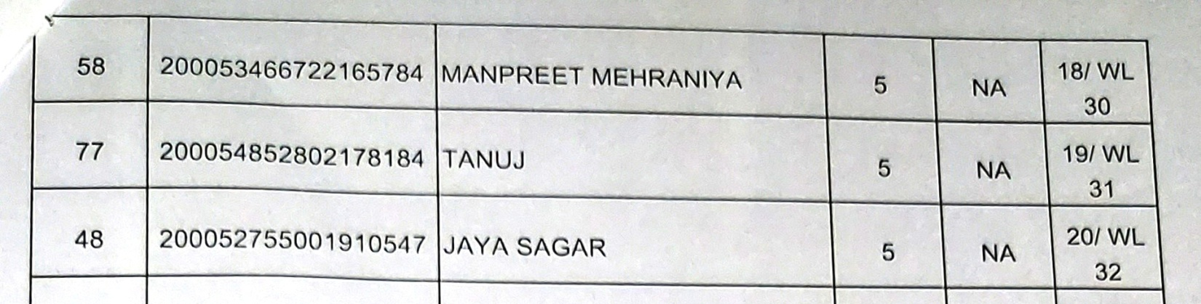

TOTAL-20 CANDIDATES
SUMMARY OF LISTS:-
- RTE = 20 CANDIDATES
- Category-1 = 17
- Category-2 =2
- SAQ =10
- Make up of shortfall (SC) =03
- Category-5 =20
TOTAL = 72 candidates
(06 ST SEATS AND 02 DA SEATS REMAIN VACANT)

